Kol Simcha Torah Gazette
For parshas yisro 5786
Vol 10 Issue 18 (Whole #484) 20 Shevat 5786/ February 7, 2025
Printed L’illuy nishmas Nechama bas R’ Noach, a”h
For a free subscription, please forward your request to keren18@juno.com
Past emails can be found on the website ShabbosStories.com under Brooklyn Torah Gazette
The Jewish Paul Revere
By Avi Abrams

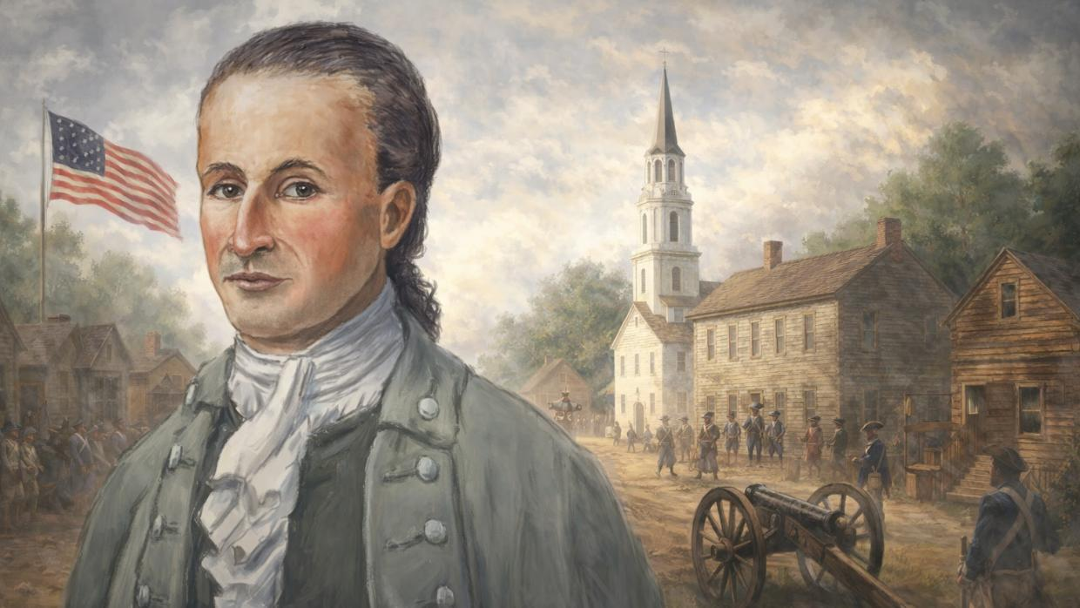
The forgotten story of Francis Salvador, the Jewish Founding Father of America.

In the summer of 1776, as revolution ignited across the American colonies, a young Jewish immigrant rode headlong into history.
He was 29 years old. Born into immense wealth and privilege in London, he had every reason to remain safely on the sidelines of the rebellion. Instead, he chose the opposite path: the untamed frontier of South Carolina, a radical political experiment called liberty, and a war whose outcome no one could yet predict.
His name was Francis Salvador.
Salvador became the first Jew to hold elective office in the Americas and the first Jew to die for the American Revolution.
Long before Jewish participation in American public life was taken for granted, Salvador shattered expectations. He became the first Jew to hold elective office in the Americas, a fierce advocate for independence when loyalty to the British Crown was still the safer choice, and ultimately the first Jew to die for the American Revolution.
Yet his story is almost unknown.
Salvador was a bridge between worlds. A Sephardic Jew whose family fled the Inquisition. An English aristocrat who rejected empire. A legislator who fought as a common soldier. He believed at great personal cost that the American “experiment in liberty” was not just a political gamble, but a moral calling.
His life would last less than three decades. But in those years, Francis Salvador helped lay the foundations of a nation that promised a place where faith and freedom could coexist.

The Fall of the House of Salvador
The story of Francis Salvador begins in the highest echelons of London’s Sephardic elite. The Salvador family (originally Rodrigues-Salvador) were descendants of Sephardic Jews who had fled the 15th Spanish Inquisition to find refuge in Amsterdam and later in London.
By the mid-1700s, they were one of the wealthiest Jewish families in the British Empire. Francis’s grandfather, Joseph Salvador, was the first Jewish director of the East India Company and a pillar of the Bevis Marks Synagogue. They lived in a world of private tutors, continental tours, and aristocratic connections.
However, a series of global calamities struck the family fortune. The Great Lisbon Earthquake of 1755—which Francis’s grandfather survived—decimated their Portuguese holdings. Later, the failure of the Dutch East India Company and shifts in the British market drained the family coffers.
Francis, then 26 years old, found himself in a position many Jews have faced throughout history, looking toward a distant horizon in search of a new country to rebuild in.

New Beginnings in the New World
Fortunately for Francis, his grandfather, Joseph Salvador, already prepared a plan B years earlier. In 1755, when Francis was still a young boy, Joseph purchased 200,000 acres of land in the South Carolina backcountry (an area later known as the Ninety-Six District) as a speculative investment and a potential refuge for Jews fleeing persecution and poverty in Europe. Little did Joseph know that his own grandson would be the first one to flee there.
Jewish investors purchasing large tracks of land was a novel concept at the time, since Jews were historically barred from land ownership in European countries. But the colonies of the New World prioritized economic growth over religious restrictions, and so laws against Jewish land ownership were non-existent or rare.
In late 1773, Francis left his wife and children in London, carrying with him a deed to only a fraction of his family’s property in the Americas; 7,000 acres of frontier land in the Ninety-Six District of South Carolina, a tract that later became locally known as "Jews’ Land”. After a long transatlantic voyage (before steamboats were invented), Francis landed in Charleston, trading his life as a London aristocrat for the rugged isolation of the American frontier.
He settled on his family’s plot of land near Coroneka Creek, where he established a plantation he named "Cornacre”. Far from a manor house, his residence was a functional home designed for the harsh "Upcountry" environment, where he focused on cultivating Indigo, a profitable but labor-intensive crop used for blue dye.
Though he was the only Jew in the region, he quickly gained the respect of his neighbors, specifically Major Andrew Williamson, who became his close friend and mentor in frontier survival. Wealthy planters of the South Carolina backcountry, men like John Rutledge and Charles Pinckney, were struck by his education, his polished manners, and his fierce intellect.
Francis Salvador's primary goal was to stabilize the plantation and prove its financial viability so he could send for his wife, Sarah, and their four children (a son and three daughters) still in London. He wrote to them with great hope, envisioning a future where they would be reunited in the land of opportunity.

A Jew in the Assembly
In December 1774, the residents of South Carolina’s Ninety-Six District did something almost unthinkable: they elected Francis Salvador to represent them in the First Provincial Congress. To understand why this was revolutionary, one must first understand the law.
Under British common law (including in the American colonies), Jews were legally barred from voting or holding office. Yet, in a display of what would later become the American spirit, his neighbors simply ignored those statutes. They saw a man of character and integrity, and they chose him to be their local leader. Francis became the first professing Jew to represent the masses in a popular assembly in the modern world.
As a member of the Congress, Francis wasn't just a "token" representative. He was a powerhouse. He helped draft the state’s first constitution and served on committees to procure ammunition and assess the security of the frontier.
Most importantly, he was a vocal advocate for total independence. At a time when many were still hesitant to break with the King, Francis Salvador, the man born into the British aristocracy, urged his fellow colonists to cast their lot with the dream of a new, free, and independent nation.

The Jewish “Paul Revere”
In 1776, the British High Command devised a strategy to crush the American Revolution from within. They encouraged their Native American allies, the Cherokee, to attack frontier settlements, hoping to force the Patriot militias to abandon the coast in order to protect their families further inland.
A messenger arrived at Francis Salvador’s plantation with news that a Cherokee war party was sweeping through the district. Salvador sprang into action.
On the morning of July 1, 1776, just three days before the Declaration of Independence was signed in Philadelphia, the frontier erupted. A messenger arrived at Francis Salvador’s plantation with news that a Cherokee war party was sweeping through the district. What Francis Salvador did next earned him the title "The Jewish Paul Revere”.
Without hesitation, he leaped onto his horse and galloped 28 miles across the rugged terrain to the plantation of Major Andrew Williamson. Along the way, he shouted warnings to the settlers, many of whom were unarmed and unaware of the impending danger. His ride allowed the local militia to organize and save hundreds of lives from the initial onslaught.
But Francis didn't stop at sounding the alarm. He personally joined the militia as a private, refusing to hide behind his legislative status. He spent the next month on the front lines, fighting in the dense forests and swamps of the South Carolina interior.

The Final Sacrifice
On the night of July 31, 1776, Major Williamson’s force of 330 men was moving toward the Keowee River. In the pitch black of night, they were ambushed by a combined force of Loyalists and Cherokee warriors. Salvador was riding at the front of the column. In the first volley of gunfire, he was hit three times. He tumbled from his horse and into the high grass of the bushes.
In the chaos of the night, a soldier found him. Salvador was scalped while still alive. When Major Williamson finally dislodged the enemy and found his friend in the dark, the scene was gruesome.
Williamson recorded the moment in his memoirs. Salvador, bleeding out and near death, asked one final question: "Have we beaten the enemy?"
Williamson replied, "Yes."
At just 29 years old, Francis Salvador became the first Jewish soldier to fall in the American Revolution.
Salvador whispered that he was glad to hear it, shook the Major’s hand, and died 45 minutes later. He never saw his wife or children again. At just 29 years old, Francis Salvador became the first Jewish soldier to fall in the American Revolution.
Although the Declaration of Independence took place nearly a month prior to his death, most Americans didn’t hear the news for weeks. Word travelled slow, especially in frontier zones like rural areas of South Carolina, and communication devices like telegraphs and same-day distribution systems hadn’t been invented yet. It’s not clear to historians whether or not Francis Salvador died knowing his vision of freedom and liberty had already been realized through the establishment of the United States.

Why the Story Matters Today
Why has Francis Salvador been relegated to a footnote in history? Perhaps it is because he died on the frontier, early on in the war, far from the dramatic stage of Philadelphia. Perhaps it is because his family remained in London, and his line did not continue as a "founding family" in America.
But for Jews around the world, Salvador’s story contains a vital spark of wisdom: the most important choices in life are made without guarantees. He committed himself to a cause that had no clear ending, no promise of success, and no assurance that history would remember him. Independence had not yet been declared (or was not yet known), victory was far from certain, and the cost was real and immediate. Yet he acted anyway.
With great courage, Frances Salvador chose to risk his life for his principles when success was nowhere in sight.
In the heart of Charleston, South Carolina, tucked away in Washington Park, stands a humble granite memorial with the following inscription:
"Born an aristocrat, he became a democrat. An Englishman, he cast his lot with the Americans. True to his ancient faith, he gave his life. For new hopes of human liberty and understanding."
The next time you think of the Founding Fathers, remember the young Sephardic Jewish immigrant who helped give birth to a new nation.
Sources:

Reprinted from the current website of aish.com

Why the Greatness of Torah
Supersedes Our Human
And Limited Perception
From the Teachings of the Lubavitcher Rebbe
Rabbi Menachem Mendel Schneerson, Zt”l
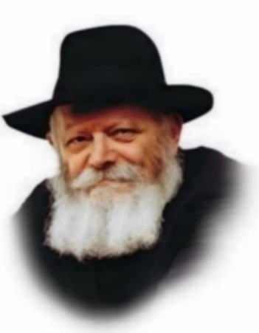
This week's Torah portion, Yitro, contains the narrative of the most definitive event in human history - the giving of the Torah on Mount Sinai. In order to understand what happened at Mount Sinai, we need to examine the concept of Torah itself.
As wisdom, the Torah is Divine, and therefore higher than any other body of knowledge on earth - "For it is Your wisdom and understanding in the eyes of the nations." As a moral guide, the Torah is the epitome of all virtue, superior to any code of ethics that can ever be devised by man. All man-made ideologies and schools of philosophy contain an admixture of good and evil, truth and falsehood; in fact, any element of truth found in a particular ideology is merely a derivative of the eternal truth of Torah.
Yet the greatness of Torah far supersedes our human and therefore limited perception. The Torah is intimately connected to all of existence, as G-d created the world according to the "blueprints" contained in the Torah. Its minutest details directly affect all of creation, determining the amount and type of G-dly influence present in the world.
Observing this fundamental relationship between Torah and reality, King David declared in Psalms, "Your statutes were music to me in my dwelling place." And yet, as explained in the Talmud, G-d was not pleased by these words of praise. King David was reprimanded for comparing the Divine wisdom of the Torah to something as mundane as song. The Torah is even greater than the mere fact that physical reality is dependent on it.
What then, is the essence of Torah? Chasidic teachings explain that Torah is simply the wisdom and will of G-d, united with Him in absolute unity. G-d and the Torah are one entity. The Holy One, Blessed Be He, has granted us the opportunity to grasp the Divine by allowing us to partake of His eternal wisdom.
All other attributes and characteristics of Torah - its unlimited enlightenment, its ethical superiority, its direct influence on existence - are only secondary to this fact, the logical outgrowth of its essential nature. As Torah is a part of an infinite, omnipotent G-d, it is only natural that its perfection extends to all these other areas as well.
This eternal quality is most obviously manifested in the inner, esoteric part of the Torah, the teachings of Chasidism. Chasidism is not limited to one particular realm, but rather animates and illuminates all of Torah, which is why it is known as "the light of the Torah." The study of Chasidismt therefore serves to prepare the world for the revelation of Moshiach and the Era of Redemption, when "the knowledge of G-d will cover the world like the waters of the ocean cover the sea bed."

Reprinted from the Parashat Beshalach 2003/5763 edition of L’Chaim, a publication of the Lubavitch Youth Organization. Adapted from Kutres Shel Torat HaChasidut of the [Lubavitcher] Rebbe.

******************************************************************
"You have seen what I did to Egypt, and that I have borne you on the wings of eagles and brought you to Me." (19:4)
R' Chaim Yosef David Azulai z"l (Chida; born in Chevron, 1724- died in Livorno, Italy, 1806) writes in the name of R' Chaim Vital z"l:
There have been those who claimed that Hashem brought plagues on Egypt only to avenge Himself for Pharaoh saying (Shemot 5:2), "Who is Hashem that I should heed His voice?"
However, had Pharaoh politely refused to send out Bnei Yisrael, Hashem would not have cared. Our verse debunks such a claim, for it teaches that Hashem not only punished Egypt, He also took us from there in a loving way. "I have borne you on the wings of eagles and brought you to Me." (Torat Ha'Chida)

Reprinted from the Parshas Yitro 5786 email of whY I Matter parsha sheet for the Young Israel of Midwood in Brooklyn as compiled by R’ Yedidye Hirtenfeld.
Rav Avigdor Miller on Are You Obligated to Love a Fellow
Jew Who Has Harmed You

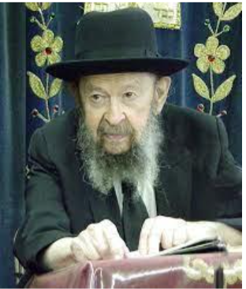

If someone was harmed by a fellow Jew, their love for him has to continue undiminished. Because Hakadosh Baruch Hu’s love for him is our yardstick for loving — not our subjective emotions. You have a right to call him to din Torah. You have a right even to tell him what wrong he did but you must continue to love him as before. And therefore, the fact that somebody wronged you does not make him possul and unworthy of the mitzvah of loving your fellow Jew.
Now I understand that these are not easy things to do, but that’s the chok haTorah! And it’s expected of us al pi din Torah.
Only when someone is no longer re’acha b’mitzvos, then there’s no mitzvah of loving him anymore. But if it is a person who believes in Hashem and he keeps the Torah in general, then it makes no difference what he did to you. You are mechuyev to love him.
QUESTION: But what about someone who doesn’t keep the Torah because he’s a tinok shenishba?
ANSWER: Now that’s a question I don’t want to discuss because tinok shenishba is not a clear-cut concept. There are many people who could have become loyal Jews, but they chose not to. But to know exactly who yes and who not, I’m not capable of telling you.
We know the general rule however. If a person is a tinok shenishba and he is an apikores, so we follow Reb Chaim Brisker, zichrono livracha, and he says, “Nebach an apikores is fort an apikores.” If he doesn’t believe in Hashem, then he doesn’t belong to us at all. If he believes in Hashem only he doesn’t know exactly what to do, that’s something else. August 1993

Reprinted from the Parshas Bo 5786 email of Torah Avigdor based on a Thursday night lecture by Rav Avigdor Miller, zt”l from May 1992.

Thoughts that Count
for Parsha Yisro

And Yitro heard (Ex. 18:1)
Yitro (Jethro) was not the only one to hear of the miracles G-d had wrought for Israel, as it says, "The nations heard it and trembled." However, Yitro was the only one who acted upon what he heard and became a Jew.
(The Kotzker Rebbe)

Remember the Sabbath day to keep it holy (Ex. 20:8)
Explains Rashi, the great Torah commentator: Take heed to remember the Sabbath at all times, so that if you happen to find something special, set it aside for Shabbat. Likewise, our Sages state that we are not to give special names to the weekdays, but to refer to them in the context of Shabbat ("first day to Shabbat, second day to Shabbat," etc.). Thus, we are constantly conscious of the upcoming Shabbat and prepare for it every day. The same applies to the Messianic Era, the "day that is entirely Shabbat and rest for life everlasting." Throughout the present "weekday" of exile we must constantly remember and remain conscious of the "Shabbat day" that is coming, preparing ourselves and everything around us for the arrival of Moshiach. (The Lubavitcher Rebbe, 11 Sivan, 5744)

For by the very thing in which they sinned was punishment brought upon them (Ex. 18:11)
A person's punishment is determined by his own judgment of others: When a Jew sees someone transgressing and immediately "sentences" that person in his heart, he is thereby fixing his own sentence, as the sin most certainly exists in him as well. (Baal Shem Tov)

You shall say to the House of Jacob and tell the Children of Israel (Ex. 19:3)
Our Sages say that the "House of Jacob" refers to the women, and the "Children of Israel" to the men. When G-d gave the Torah, He told Moses to first approach the women and only after the men. Since the exodus from Egypt occurred by virtue of the righteous women of that generation, when G-d gave the Torah, the women were given preference. The final Redemption, too, will be by virtue of the righteous women, as the Midrash states: "All generations are redeemed by virtue of the righteous women of their generation." Thus, the women will be first to receive the wondrous teachings of Moshiach. (Sichot Kodesh, Yitro, 5749)

Reprinted from the Parashat Yisro 2003/5763 edition of L’Chaim, a publication of the Lubavitch Youth Organization.

Why Give a “Get” If
I’m Not Religious?
By Levi Avtzon

Dear Rabbi,
My wife and I are getting divorced. You know us, we barely came to shul on Yom Kippur, and I won't tell you where we would dine out back when we were together. She wants me to give her a get, which I understand to be a religious divorce, but I feel like it's unnecessary. We lived a largely secular life together and I see no reason to have a religious ending to our failed marriage. Can you explain what a get is and why it would be necessary in our situation?
Jeff

Dear Jeff,
You're asking a fair question. You've built a largely secular life, and now that the marriage is ending, you want to close this chapter cleanly. From where you're standing, adding a religious element to a life that didn't really operate within religion feels unnecessary. Most people never think about a get until it's suddenly on the table, so your hesitation makes sense.


Art by Sefira Lightstone

But this is where your true colors as a mensch will show.
As one wise person put it, there are three ways to gauge someone's character: How they walk through the door, what they do once they are inside (i.e., how they engage, converse, and present themselves), and how they close the door behind them as they leave. The last is the most revealing. You can enter gracefully. You can behave well while inside. But if you slam the door behind you when leaving, you negate everything that came before.
Your marriage began in goodness. Even the ones that end badly once began with a spark of grace. You tried to build a life together. You shared moments that were real. Even if the road forked, the beginning and the original commitment deserve to be honored. Sometimes, the only way left to honor her dignity and your character is in how you finish.
And that is where the get comes in.
A get is the Jewish act that formally ends a marriage. It is not a sermon or a public ritual. It is a handwritten document prepared by a trained scribe and delivered from husband to wife under rabbinic supervision. That moment releases her fully. Without it, in Jewish law, you remain connected long after the civil courts have closed the file.
So why bother if you don't believe in it?
Part of the answer is practical (and potentially painful). Without a get, she cannot remarry according to Jewish law (and neither will you be able to marry). She is still married to you.
If she does remarry without the get, any children born from that union face a devastating designation in Jewish law: mamzer. It is one of the most painful identities a child can carry. It destroys their ability to marry within the community and causes untold havoc as they try to navigate their identity as a Jew. All because of one document you didn't hand over before they were even conceived.
That undelivered document is taking hostage the woman you claimed to love, and her future for all generations.
Whether you believe in it or not, the consequences are real for both of you.
Mystically, there is another idea worth contemplating. A Jewish marriage is not merely logistics and paperwork. Something deeper was happening that day. Two lives opened toward each other. Two stories wove together. Our tradition calls it the joining of souls. You don't have to speak that language every day to recognize that a bond existed beyond what a court stamped on paper.
The get finishes what the marriage started.
You don't need to be religious to acknowledge that if something began with sanctity (even lightly, even unknowingly), the honorable thing is to close it with care rather than indifference. And the process itself is not complicated. A couple of hours. The money it costs to pay for the time of the court overhead and scribe (and if money and logistics are truly the issue, the courts are normally more than willing to accommodate). No speeches. No pressure. You show up, you participate, and you walk away knowing you've done right by someone you once loved.
You once cared enough to stitch your life to hers. Even if that stitch has come undone, you can choose not to leave a knot tied inside her future.
Giving a get is not about surrendering belief. It is the last responsible act available when a shared story has concluded. It says: Although we cannot continue walking the road together, I will not block you from moving forward freely. Once you give it, you’ve truly broken your ties and freed yourself to move upward and onward.
Divorce reveals us. It shows whether the kindness that opened the story had substance or only shine. And sometimes, the most lasting thing you offer the person you once loved is the manner in which you let them go. When you finish with generosity and dignity, something in the story completes itself. Something becomes whole again, if only your own integrity.
Don't slam the door on your way out. And don't hold her hostage. You are so much better than that.
Reprinted from the current website of Chabad.Org

